Bisection Method

This is a simple line search method to solve f(x) =0, given an interval, halving the interval at each iteration.

Solve f(x) =0 over an interval [a,b] such that $0∈$ [a,b] and f(a)f(b)<0

Method:

1. Determine m=(a + b)/2
2. If f(m)=0,stop.m is the desired point such that f(m)=0
3. If f(m)f(a)<0,b=m. Go to step 1
4. If f(m)f(b)<0,a=m. Go to step 1
5. If f(m) doesn’t converge soon enough to 0,set a tolerance value $∈≈0$ and repeat until   
   |a-b|=

Having declared a tolerance value $∈$,the number of iterations N is given by:

N= $\log{\frac{∈_{o}}{∈}}$ where $∈_{o}$ =b-a, the value of the initial bracket size.

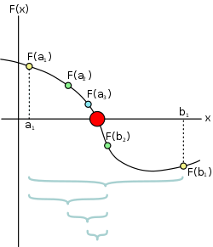

The figure shows the working of the bisection method, the red dot represents the required root of the function.

Golden Section Search Method

This is a dichotomous search method to find the local minima of a given unimodal function over an interval.

$Min {f(x)}_{x∈R}$ over an interval [x1,x3]

Consider the following figure:

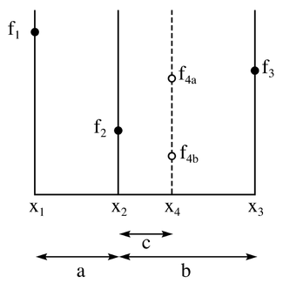

We choose 2 points x2,x4 in the interval [x1,x3] such that:

X4 = x1 + b = x1 + a + c

X2 = x3 - b

In other words x2,x4 are symmetrically placed about the interval [x1,x3] with a distance of b.

We choose a and b such that $\frac{b}{a } = \frac{1+√5}{2}$, the golden ratio ( $∅)$.The golden ratio $∅$ has a property wherein $\frac{1+∅}{∅}= ∅$. Hence the name Golden Ratio Search.

Method:

1. Determine f(x2),f(x4) let them be f2,f4 respectively. There are two possible scenarios:  
   i. f(x1)>f2,f2<f4.In this case the interval now becomes [x1,x4].   
   ii. f2>f4,f4<f(x3).In this case the interval now becomes [x2,x3].  
   We arrive at those conclusions as we deal with unimodal functions.
2. The number of iterations for termination of this method depends on the precision we set,as the iterations increase the interval becomes narrower and narrower. After each iteration we decrease the interval by 38.19% (1/1+ $∅$%).We eventually identify the minimum value of the function to belong to a narrow interval, the narrowness of which depends on the number of iterations performed.

Fibonacci Search

This is also a dichotomous search technique very similar in operation to Golden Section search. Here the interval does not reduce by a constant factor after each iteration; this factor is dependent on Fibonacci numbers.

$Min {f(x)}_{x∈R}$ over an interval [a,b]

f(x) is a unimodal function.

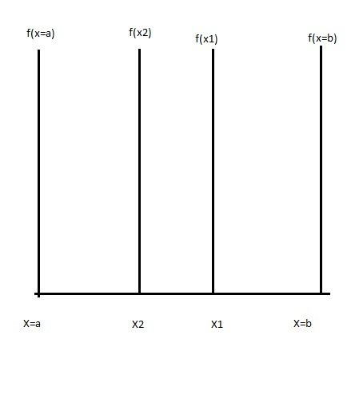

If a and b are separated by an interval $I_{0 }$, the interval ${ I}_{k}$ obtained after k iterations is given by:

$$I_{1}=I_{0 } × \frac{F_{n-1}}{F_{n}}$$

$$I_{2}=I_{0 } × \frac{F_{n-2}}{F_{n}}$$

And so on….

$$I_{k}=I_{0 } × \frac{F_{n-k}}{F_{n}}$$

NOTE: $F_{n}=F_{n-2}+F_{n-1}$ n>=2, $F_{0}=F_{1}=1$

Here n is determined by the desired accuracy.

If an interval of size 3 is to be ultimately reduced to an interval of 0.15 within which the minima is to be found, the desired reduction ratio is hence 20, we choose $F_{n}$ =21,the next larger Fibonacci number.We then determine the interval size at each iteration and proceed as in the Golden Section Ratio method.